Mobile Application Development (19COB155)

Christos Vrionides B811469

App Specification:

I will be making a notepad app where I can create new notes and save them to the database. After creating the note and entering the details of the note there will be a screen where you can view all your notes and when you open a certain note you will be able to edit it. On the page that you view the notes it will show you the title of the note and the date and time it was created or the last time it was edited. Also, you will be able to set notification reminder for the note and also share the note

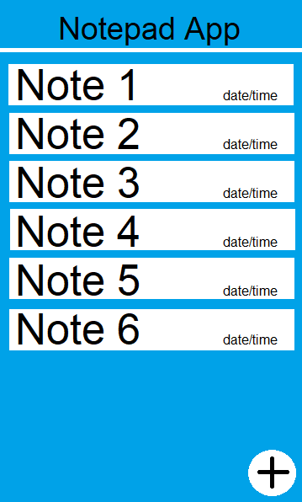 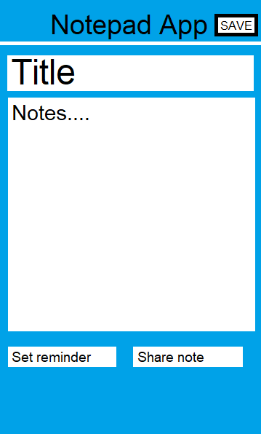

Using the( + ) icon at the bottom right will create you a new note like in the second picture, when you are finished editing the note you press save at the top right and creates a new note(e.g. here it will give you a Note 7 in screen 1) and will automatically add the date and time it was saved. To edit or view, you click on the note you want and will take you to screen 2 but with all the previous note details already in. At the bottom of screen 2 you will be able to set a notification for the note as a reminder and share the note on messaging apps